Technologies for a FAIRer Use of Ocean Best Practices

Pier Luigi Buttigieg, AWI, (Germany), pbuttigi@mpi-bremen.de
Pauline Simpson, IOC-UNESCO/IODE - CCMI (Cayman Islands), psimpson@reefresearch.org
Jay Pearlman, IEEE (France), jay.pearlman@ieee.org
Peter Pissierssens, IOC-UNESCO/IODE (Belgium), p.pissierssens@unesco.org
Scott Caltagirone, Element 84 (USA), scott@element84.com
Mark Bushnell, NOAA-IOOS (USA), mark.bushnell@noaa.gov
Juliet Hermes, SAEON (South Africa), juliet@saeon.ac.za
Emma Heslop, IOC-UNESCO/GOOS (France), e.heslop@unesco.org
Johannes Karstensen, GEOMAR (Germany), jkarstensen@geomar.de
Frank Muller-Karger, Univ South Florida, (USA), carib@usf.edu
Cristian Muñoz, SOCIB (Spain), cmunoz@socib.es
Francoise Pearlman, IEEE (USA), francoise.pearlman@ieee.org

Introduction
The publication and dissemination of best practices in ocean observing is pivotal for multiple aspects of modern marine science, including cross-disciplinary interoperability, improved reproducibility of observations and analyses, and training of new practitioners. Often, best practices are not published in a scientific journal and may not even be formally documented, residing solely within the minds of individuals who pass the information along through direct instruction. Naturally, documenting best practices is essential to accelerate high-quality marine science; however, documentation in a drawer has little impact. To enhance the application and development of best practices, we must leverage contemporary document handling technologies to make best practices discoverable, accessible, and interlinked, echoing the logic of the FAIR data principles [1].
Implementation of an Advanced Repository for Ocean Best Practices
The future of best practice management rests upon resources which enable the efficient, targeted discovery and access of documented methodologies with innovative, community-tuned search functionality. Such systems would depend on a trusted and stable repository serving as a focal point for the harmonization of both reporting standards and technologies. Funded by AtlantOS (EU H2020), ODIP, and NSF, we are currently enhancing the IOC-UNESCO/IODE OceanBestPractices Repository (OBP-R) https://www.oceanbestpractices.net/ [2]. In addition to the OBP-R’s existing full text and metadata-driven functionality, we are enabling the discoverability of content through granular indexing via text-mining and ontology-based semantic search tools. Our solution operates in two directions: 1) using expert knowledge represented in community ontologies (e.g. [3] to enhance access to and mobilisation of best practices) while 2) using the content of the best practices to enrich the ontologies with ocean-relevant material and spur new research initiatives in ocean-oriented artificial intelligence.

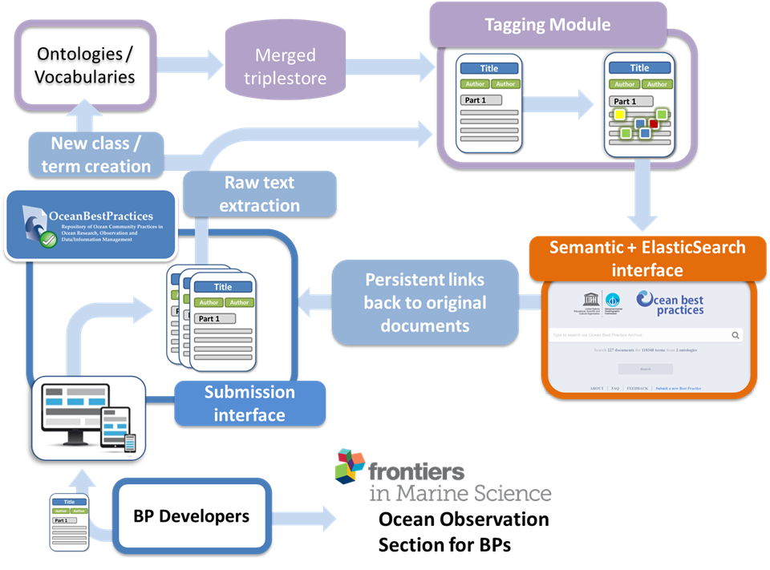
Figure 1: Simplified schematic of a semantically enhanced Best Practice Repository

A new, semantically enhanced ocean best practices portal has been incrementally implemented since April 2018 and is progressing through beta testing. In this contribution, we will describe the current state and future directions of our prototypical system. In the next year, we aim to integrate ontologies and thesauri covering more ocean-relevant themes, including sensors and societal goals such as the UN Sustainable Development Goals. We will develop closer technical ties to the academic journal associated with the OBP-R, ensuring that best practice developers are not only discoverable, but also credited and recognised in the literature. Further, we will expose the open source code driving each of the system’s modules (Fig 1), inviting the community to offer new or revised modules to further pursue a future of Fairness for ocean best practices.

References
1. Wilkinson, MD; Dumontier, M; Aalbersberg, IJJ; Appleton, G; Axton. M; Baak, A. et al (2016) The FAIR Guiding Principles for scientific data management and stewardship. Sci Data. 2016;3: 160018.
2. Pearlman, J; Buttigieg, PL; Simpson, P; Muñoz Mas, C; Heslop, E; and Hermes. J. (2017) Accessing Existing and Emerging Best Practices for Ocean Observation - a new approach for end-to-end management of Best Practices. IEEE/MTS OCEANS’17 Proceedings – Anchorage, pp.1-7.
3. Buttigieg, PL; Pafilis, ;, Lewis, SE; Schildhauer, MP; Walls, RL; Mungall, CJ. (2016) The environment ontology in 2016: bridging domains with increased scope, semantic density, and interoperation. J Biomed Semantics. 2016;7: 57.

